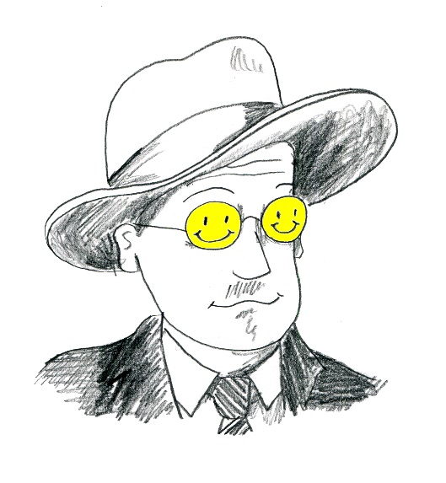 | Come Celebrate Bloomsday  In Worcester Massachusetts, Tuesday June 16th 2026
The book Ulysses follows Leopold Bloom and Stephen Dedalus as they wander through Dublin on June 16, 1904, the date James Joyce had his first encounter with his wife to-be Nora Barnacle. You can join us to listen or read a part of his story. Sponsored by the Worcester County Poetry Association.

Site | Time | Chapter
Bancroft Tower  Bancroft Tower Rd.  Worcester MA | 830-10:00 AM | Telemachus: STATELY, PLUMP BUCK MULLIGAN ….
Classical High  21 Irving Street  Worcester MA | 10:00 -12:00 AM | Nestor: YOU, COCHRANE, WHAT CITY SENT FOR HIM?
Birch Tree Bread Co.  138 Green Street  Worcester MA | 12:00 – 1:00 PM | optional reading – your choice
Library  3 Salem Square  Worcester MA | 1:00 – 3:00 PM | Aeolus: IN THE HEART OF THE HIBERNIAN METROPOLIS
Tidepool Bookstore  372 Chandler St.  Worcester MA | 3:00 -5:00 PM | Proteus: INELUCTABLE MODALITY OF THE VISIBLE
Ralph’s Diner  148 Grove Street  Worcester MA | 5:00 -6:00 PM | Ithaca: WHAT PARALLEL COURSES
Oak Barrel Restaurant  229 Grove Street | 6:00 – 800 PM | Penelope: YES BECAUSE HE NEVER DID A THING LIKE THAT BEFORE….
Graphic courtesy of K-Fai Steele

